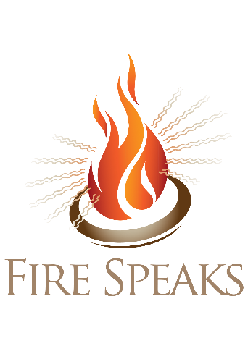
Although the rules may change again before May 15, currently we are operating under the religious exemption which allows larger gatherings with multiple households.
- We ask that you stay home if you have symptoms of COVID-19 or have been in contact with someone who has COVID-19 within two weeks of the event. We will check your temperature and ask about symptoms when you check in.
- Wear your face mask (no scarves, fleece or neck gaiters) when you arrive and when you cannot maintain at least six feet distance from other people (with the exception of family and household members).
- Same household will be able to sit together. Otherwise we ask that you sit six feet apart from non-household members.
- We will have a table with hand sanitizer.
- We will not be having a potluck this year, you may bring your own picnic dinner and eat it while staying at a distance from non-household members.
- We will not be supplying chairs. There are backless benches built in to the ground, if you wish to sit on those please bring pads/pillows as needed. We ask you to bring your own folding chair which can be set up along the sides and back of the area with benches.

